H.T No
Regulations:
A18

Sreenidhi Institute of Science and Technology
(An Autonomous Institution)
Code No: 7KC81 Date: 06-July-2023 (FN)

B.Tech III-Year I- Semester External Examination, July - 2023 (Supplementary)
STRUCTURAL ENGINEERING (CIVIL)

Time: 3 Hours Max.Marks:70

Note: a) No additional answer sheets will be provided.
b) All sub-parts of a question must be answered at one place only, otherwise it will not be valued.
c) Missing data can be assumed suitably.
Bloom's Cognitive Levels of Learning (BCLL)

Remember | L1 | Apply | L3 | Evaluate | L5
Understand | L2 | Analyze | L4 | Create | L6

Part - A Max.Marks:20

Answer all QUESTIONS.

 |  | BCLL | CO(s) | Marks
1 | Outline the main objects of structural analysis. | L1 | CO1 | [2M]
2 | Calculate the maximum deflection of a fixed beam carrying udl of 8 kN/m. The span of beam is 10 m. Take E = 200kN/m2 and I = 5x10⁷ mm4. | L5 | CO2 | [2M]
3 | Moment Distribution Method is applicable for which type of structure? | L3 | CO3 | [2M]
4 | What is distribution factor? | L2 | CO4 | [2M]
5 | What is the purpose of Kani’s method of analysis? | L1 | CO5 | [2M]
6 | What is plastic moment of resistance? | L1 | CO6 | [2M]
7 | What is the bending moment at a point where shear force changes its sign? | L5 | CO | [2M]
8 | What are the quantities in terms of which the unknown moments are expressed in slope-deflection method? | L3 | CO | [2M]
9 | Define stiffness of joint. | L2 | CO | [2M]
10 | Prove when far end is fixed carry over factor is ½. | L1 | CO | [2M]

Part – B Max.Marks:50
ANSWER ANY FIVE QUESTIONS. EACH QUESTION CARRIES 10 MARKS.

 |  |  | BCLL | CO(s) | Marks
11. |  | Find the degrees of static indeterminacy and kinematic indeterminacy for the pin jointed plane truss shown?  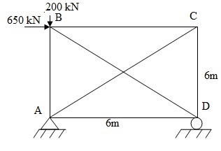  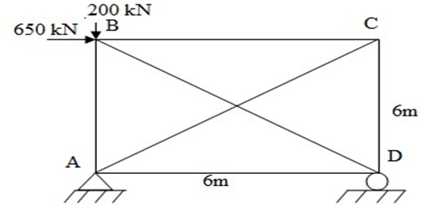 | L5 | CO1 | [10M]
12. |  | A cantilever beam of length 6m is carrying a point load of 70kN at a distance of 4m from the fixed end. The cantilever is propped rigidly at free end. Determine the reaction at the rigid propped draw SF and BM diagrams  .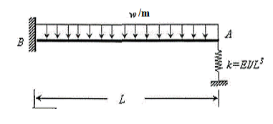 | L4 | CO2 | [10M]
13. |  | A continuous beam ABCD consists of three spans and support A and D are fixed and is loaded as shown in fig. Determine the bending moments at supports. and plot the bending moment diagram.  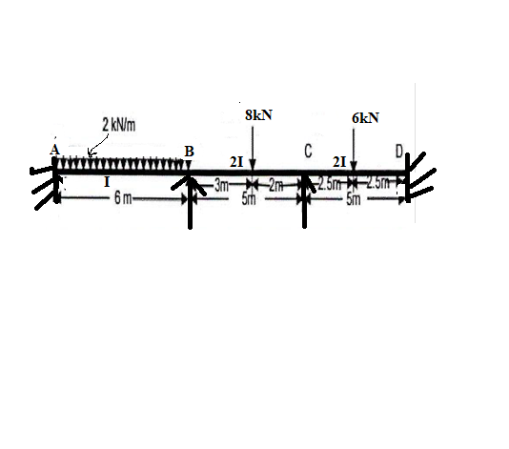 | L5 | CO3 | [10M]
14. |  | Analyze the continuous beam shown in Fig. by  moment distribution method. The support ‘B ‘settles by below 5mm. Assume EI constant for all members  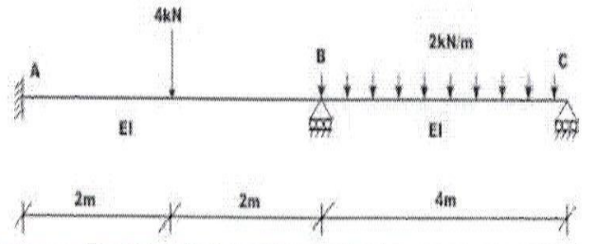 | L4 | CO4 | [10M]
15. |  | Determine the moments at supports if support B yield by 10 mm  under the given loading for the beam as show in figure below by Kani’s method, E=2.05x10 ⁵N/mm², I=30x10 mm⁴.  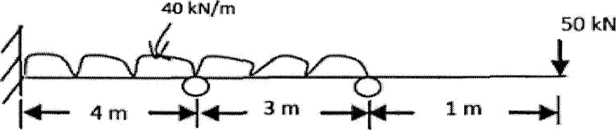 | L4 | CO5 | [10M]
16. |  | Determine the forces in the truss shown in Fig. All the members have same axial rigidity  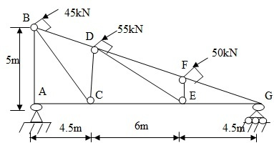 | L5 | CO6 | [10M]
17. |  | Find the degrees of kinematic indeterminacy for the pin jointed plane truss shown?  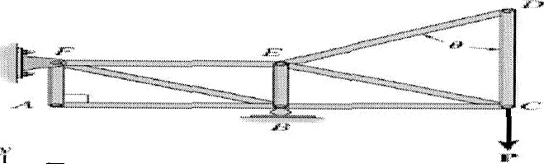 | L4 | CO1 | [10M]
18. | a) | Differentiate non-sway and sway type portal frames with examples. | L3 | CO4 | [4M]
 | b) | Write advantage and the purpose of Kani’s method of analysis? | L2 | CO5 | [3M]
 | c) | Explain the load factor and shape factor with an example. | L2 | CO6 | [3M]

-- 00 -- 00 –

